NAME:____________________

Year 10 Homework Booklet
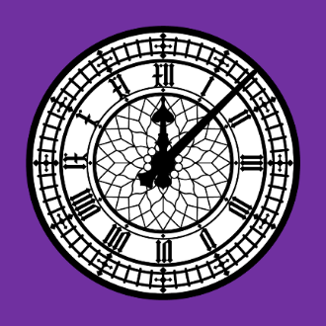
HT6
History
Revise
Retrieve
Repeat
 | Retrieval and Notes? | Dual coding? | Comments
WK1 |  |  | Crime grid
WK2 |  |  | USA grid
WK3 |  |  | Ludlow grid
WK4 |  |  | Crime grid
WK5 |  |  | USA grid
WK6 |  |  | Ludlow grid
WK7 |  |  | Crime grid

TASK 1 Retrieval Practice Test – Crime KEY : From memory: retrieval practice // From notes/videos

 | Society | Crime | Enforcement | Punishment
1250-1500


1500-1750

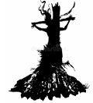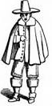

1750-1900

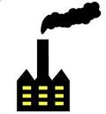

1900+



TASK 2 Retrieval Practice Test – USA KEY : From memory: retrieval practice // From notes/videos
 |  | White Settlers |  |  |  | African Americans | Native Americans (Indigenous peoples)
1789-1838 |  | Moving to new lands |  |  |  | Issues concerning slavery | Removing Indians from the East | 1789-1838
1839-1860 |  | Early migrants | Mormons |  | Gold miners |  | Plains Indians (inc. Lakota Sioux) | 1839-1860
1861-1877 |  | Causes and build-up to the Civil War |  | Approaches during the Civil War |  | Reconstruction | Indian Wars, 1861-77 | 1861-1877
1861-1877 |  | Railroads | Cattle ranchers – changes |  | Homesteaders – cause, problems, solutions |  |  | 1861-1877
1877-1900 |  | Cities, Big Business, workers, unions |  |  |  | African Americans | Native Americans | 1877-1900
Task 3 LUDLOW CASTLE KEY : From memory: retrieval practice // From notes/videos

 | Buildings | People & Jobs | Historical Events | Comparison to other castles
1085-1280 Norman Fortress  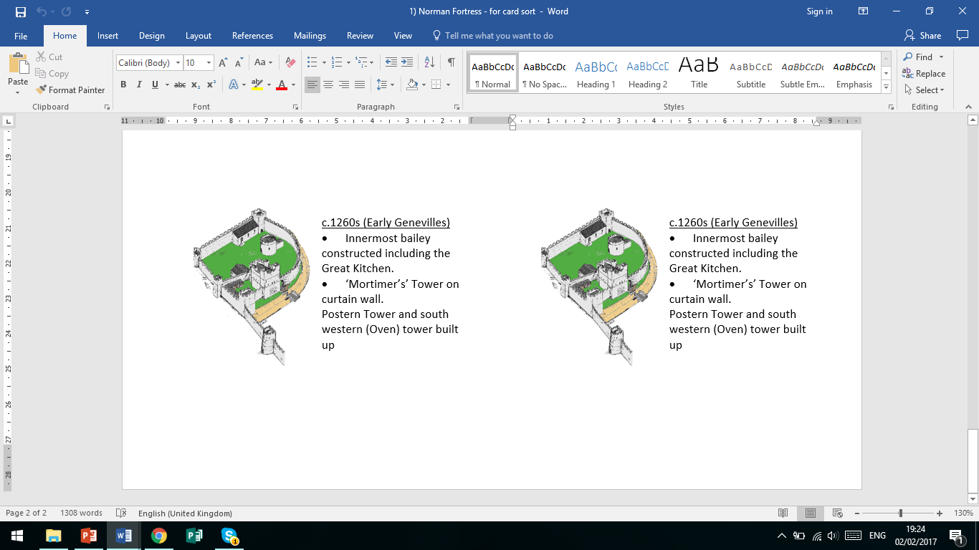 | (Include reasons for choice of site)
1280-1460  Fortified Palace  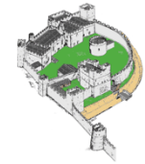 |  |  |  | 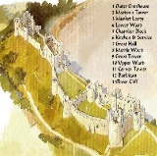
1460-1689
Council of Marches
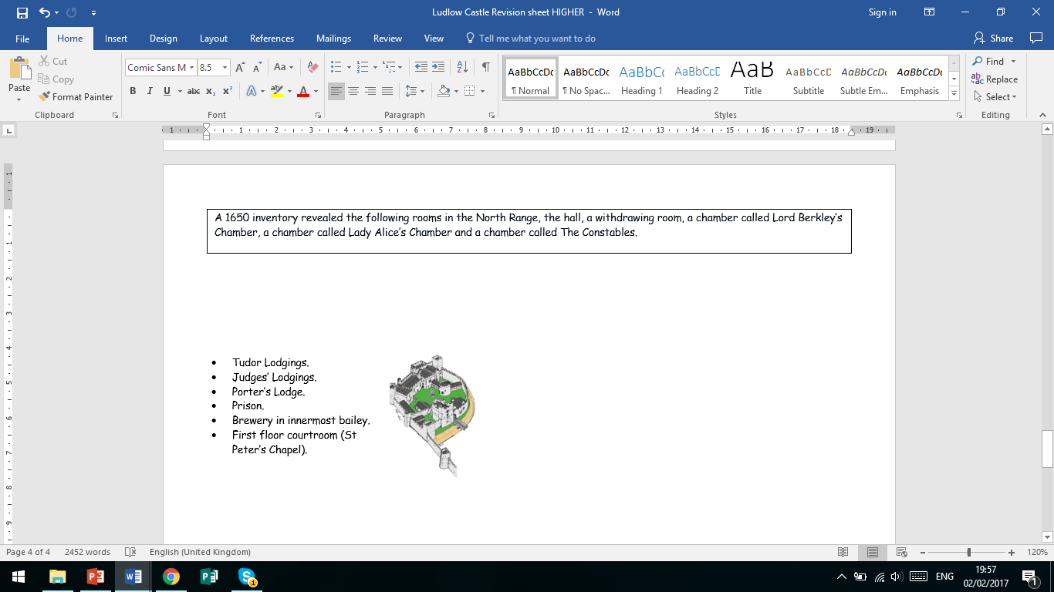

Problems for historians (select time period) | Solutions for historians

TASK 4 Retrieval Practice Test – Crime KEY : From memory: retrieval practice // From notes/videos

 | Society | Crime | Enforcement | Punishment
1250-1500

1500-1750

1750-1900

1900+

TASK 5 Retrieval Practice Test – USA KEY : From memory: retrieval practice // From notes/videos
 |  | White Settlers |  |  |  | African Americans | Native Americans (Indigenous peoples)
1789-1838 |  | Moving to new lands |  |  |  | Issues concerning slavery | Removing Indians from the East | 1789-1838
1839-1860 |  | Early migrants | Mormons |  | Gold miners |  | Plains Indians (inc. Lakota Sioux) | 1839-1860
1861-1877 |  | Causes and build-up to the Civil War |  | Approaches during the Civil War |  | Reconstruction | Indian Wars, 1861-77 | 1861-1877
1861-1877 |  | Railroads | Cattle ranchers – changes |  | Homesteaders – cause, problems, solutions |  |  | 1861-1877
1877-1900 |  | Cities, Big Business, workers, unions |  |  |  | African Americans | Native Americans | 1877-1900
Task 6 LUDLOW CASTLE KEY : From memory: retrieval practice // From notes/videos

 | Buildings | People & Jobs | Historical Events | Comparison to other castles
1085-1280 Norman Fortress | (Include reasons for choice of site)
1280-1460
Fortified Palace
1460-1689
Council of Marches

Problems for historians (select time period) | Solutions for historians

Task 7 Retrieval Practice Test – Crime KEY : From memory: retrieval practice // From notes/videos
 | Society | Crime | Enforcement | Punishment
1250-1500

1500-1750

1750-1900

1900+

